**Project Title**

SLA Management for Hardware Group - Priority 4

**Project Description:**

To implement and manage an SLA in ServiceNow for hardware-related incidents categorized as Priority 4, ensuring incidents are addressed within 16 business hours, pausing the SLA when the incident is on hold, and stopping the SLA when the incident is resolved or closed.

**Team Members:**

* **Muhammed Fadil-****muhammedfadhil077@gmail.com**
* **Yeshwanth-****yeshwant748@gmail.com**
* **Shabeer Ahamed-****tn76black@gmail.com**
* **Mohamed Fazil J-****mdfazil216@gmail.com**

**Implementation:**

**………………………………………………………………………………………….**

**Activity-1**

1. Open service now developer Instance
2. Click on All
3. Search for SLA Definition

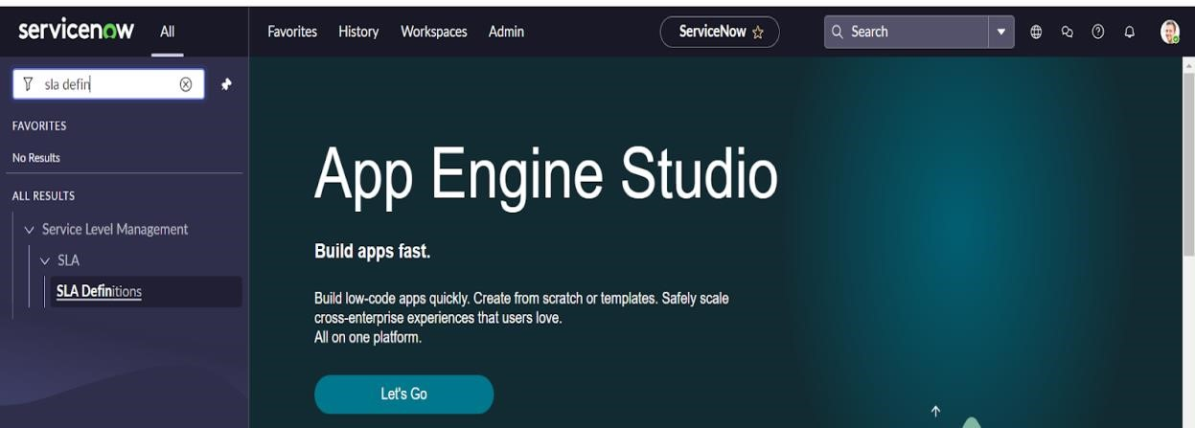

1. Create New
2. Fill the information as mentioned below

Name : Hardware Group - Priority 4

Type : SLA

Target : Response

Table : incident

Duration : 1 hour

Schedule source : No schedule

Leave the other things default

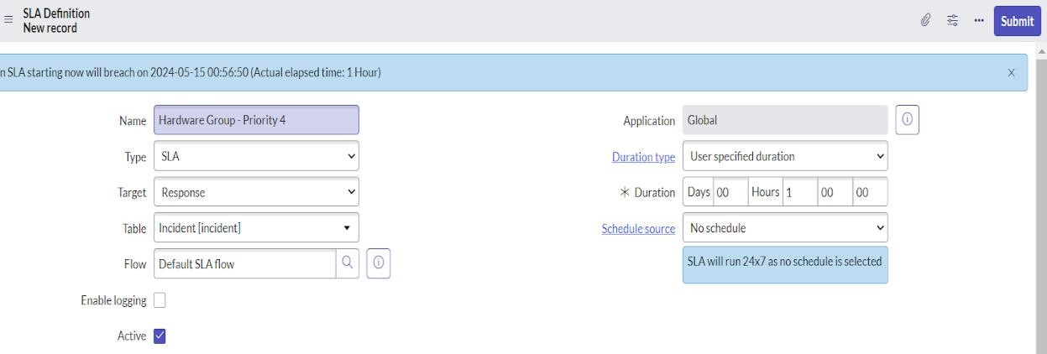

1. Under start condition fill the given information

Active>>is>>true

Priority>>is>>4-low State>>is>>New

1. Under when to cancel choose

When start condition is not met.

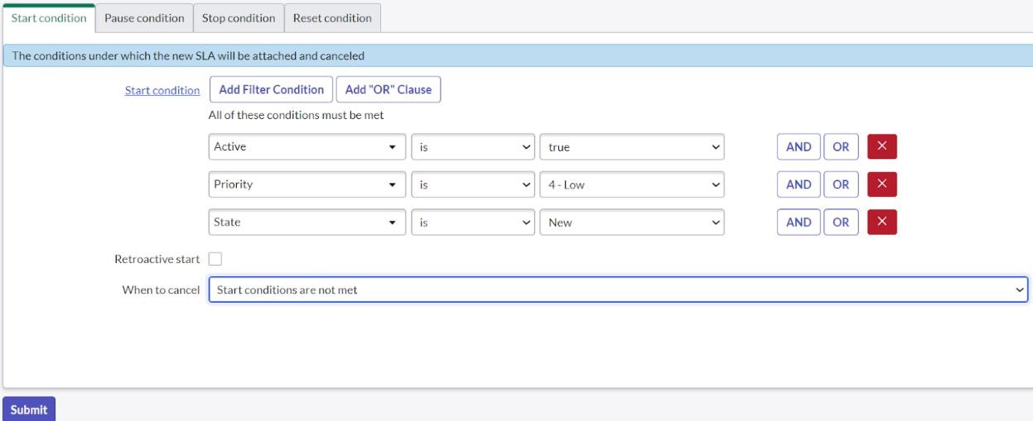

1. Under stop condition

Assignment group >> is not empty

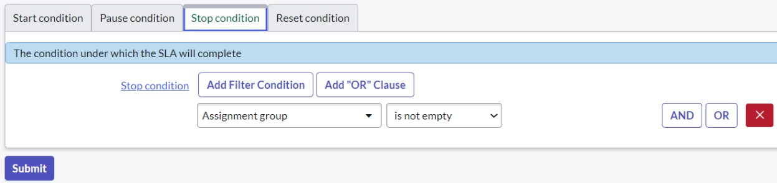

1. Click on submit.

**Activity - 2:**

1. Click on All
2. Search for SLA Definition



1. Create New
2. Fill the information as mentioned below

Name : Hardware Group-Resolution

Type : SLA

Target : Resolution

Table : incident

Duration : 16 hour

Schedule source : No schedule

Leave the other things default

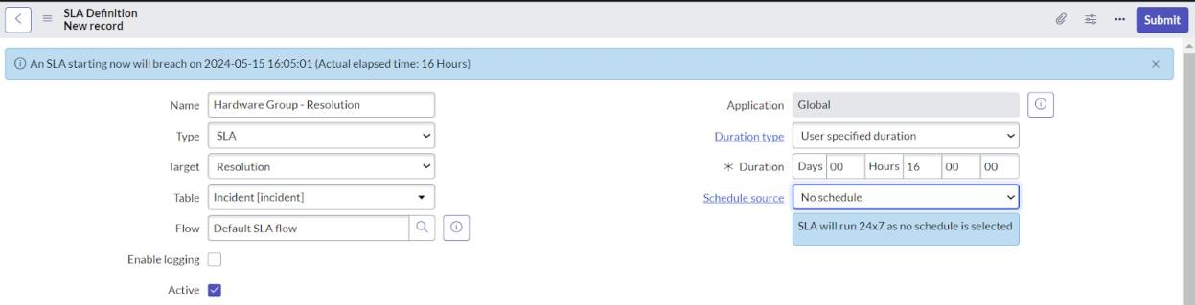

1. Under start condition fill the given information

Assignment group >> is not empty

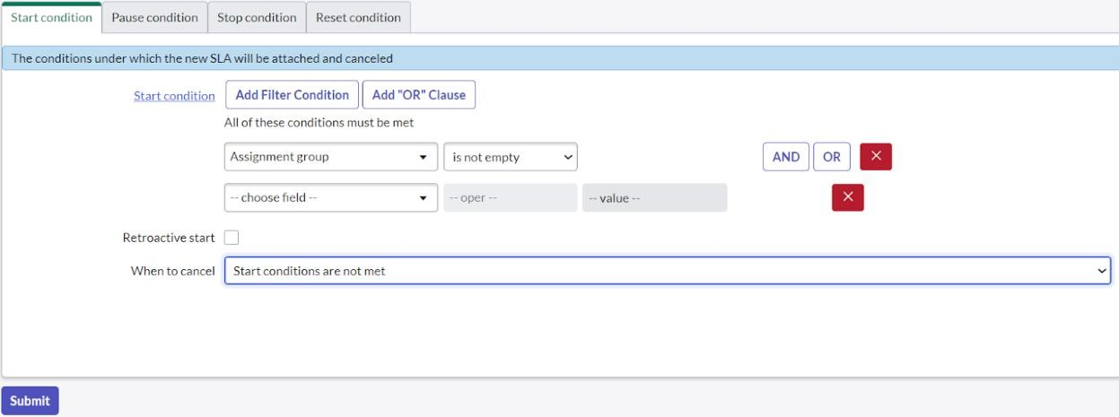

1. Under pause condition fill the following information state>>is>>onhold
2. Under when to resume choose

When pause conditions are not met

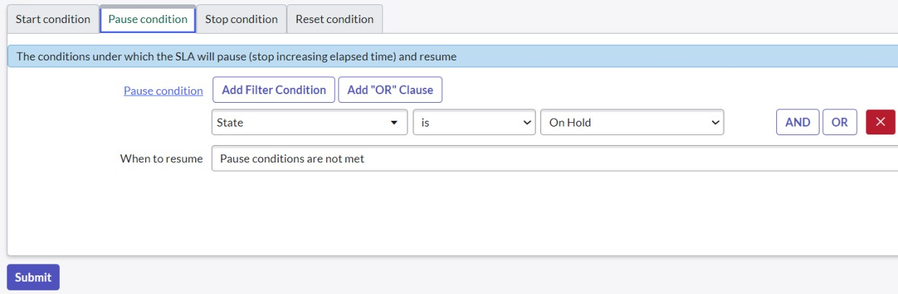

1. Under stop condition fill the following information

State>>is one of>>resolved,closed

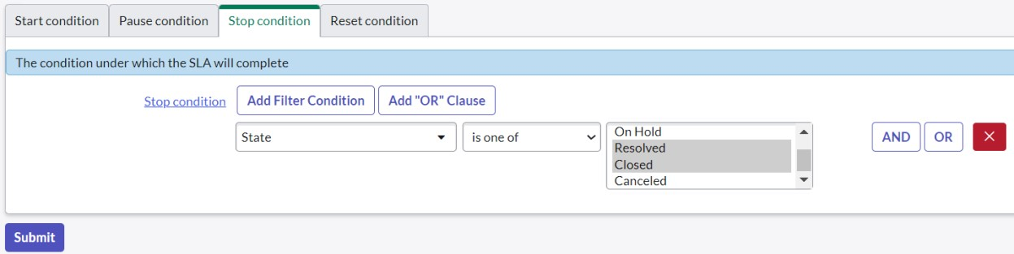

1. Click on submit.

**MyResults:**

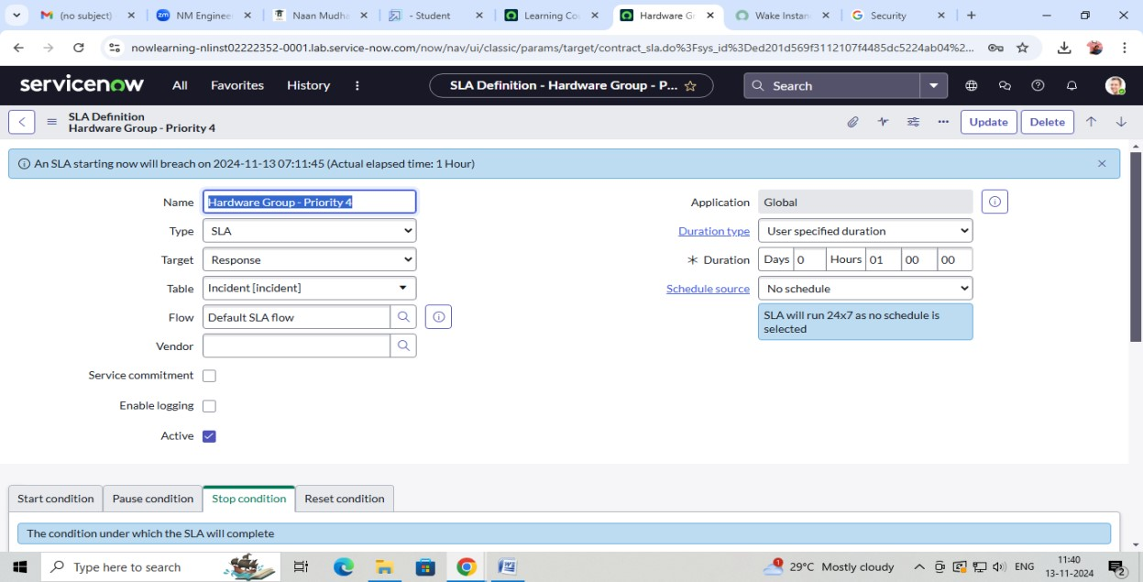

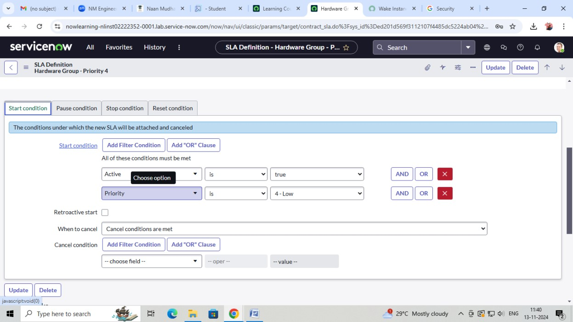

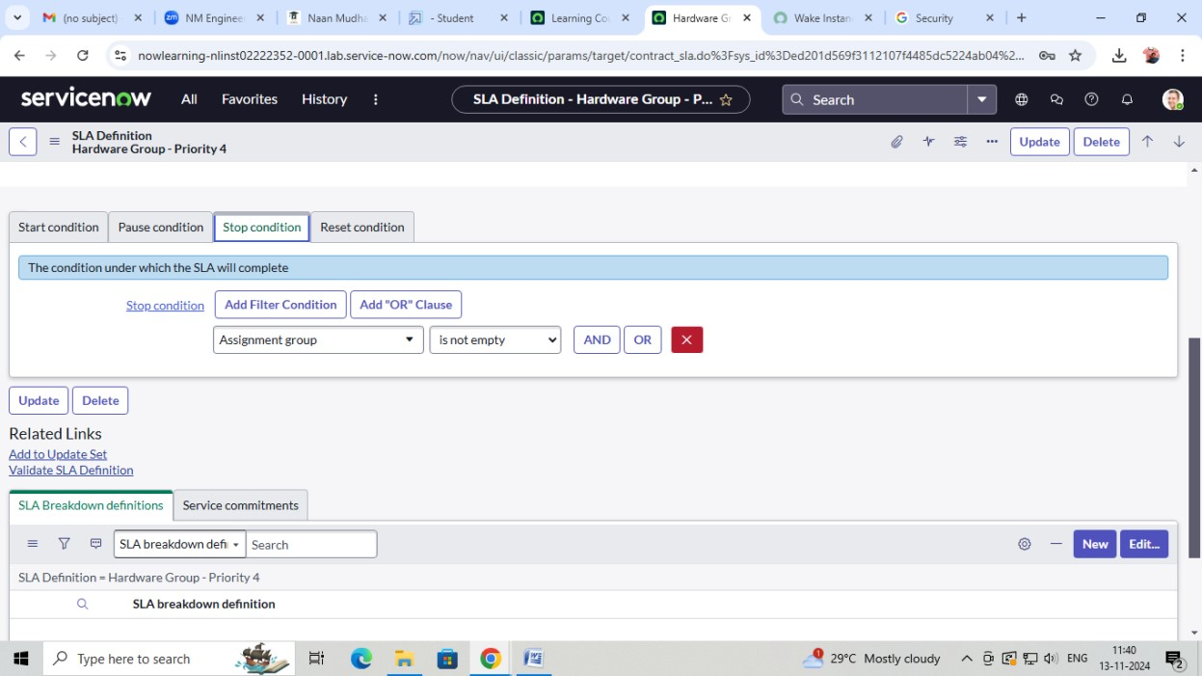

**Project – 2:**

